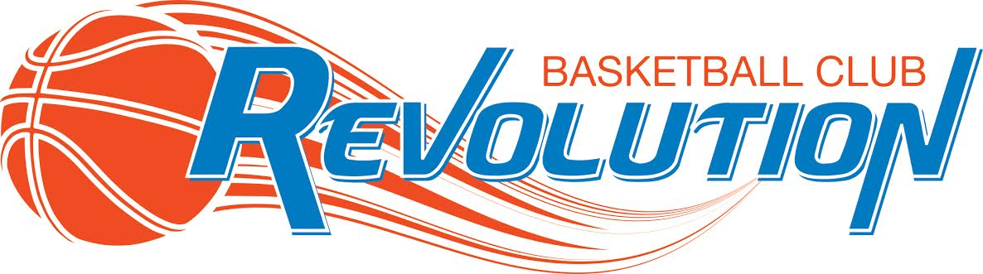

RETURN TO SPORT PLAN
Updated August 24, 2020 – Phase 3

We will be following the five principles from BC’s Restart Plan:
1. Personal Hygiene - frequent hand washing/sanitizing; no handshaking, high fives or hugging
2. Stay Home if you are sick - routine daily screening
3. Environmental Hygiene - frequent cleaning and sanitization of equipment
4. Safe Social Interactions - small groups; maintain distance; outdoor over indoor
5. Physical Modifications - spacing; movement of people

The Revolution Basketball Club will operate under enhanced health and safety protocols, including:
- Participants will maintain physical distancing
o Two meters apart from one another
o Non-contact activities only
o No handshaking, high fives, hugging, etc.

- Reduce touch points with respect to equipment
o See next section for further details

- Focus on skill development or low risk activities
o Activities should be those typically done in practice and/or training environments
o Individuals may have had limited exposure to physical activity for the past few months. Ensure that activities consider their ability that day (not where they previously may have been) and have injury prevention top of mind

- Remain community focused
o Stay within the home sport community
o Avoid cross-regional, inter-provincial or cross-country travel. International travel is subject to quarantine rules.

- Limit large gatherings
- Parents and spectators will not be permitted in the gym
- Designated drop-off and pick-up locations

Examples of possible sport-specific modifications:
• For team sports – focus on drills and training exercises in small groups
• For contact sports – move to non-contact skills training in small groups
• Use of side by side courts/lanes – limit the number of people per court/lane, create directional flow of traffic

*Update
In Phase 3:
• Close physical proximity should still be minimized as much as possible.
• In sports and activities that generally involve interaction between participants at a distance of less than two metres, sport organizations should:
o modify the activity or rules to keep participants at a safe distance;
o limit the number and duration of contacts between different participants (when physical distancing is not possible);
o enforce physical distance when not on the court (e.g.- dressing rooms, hallways, team benches, staging areas, etc.
GUIDELINES AND CONSIDERATIONS
FOR A SAFE RETURN TO BASKETBALL

● Participant safety is paramount.
● Adhere to ALL public health restrictions in the school community
(e.g. maximum group gatherings, facility access)
● Program will be local only. No travel at this time.
● Basketball activities will focus on skill development only. Competition will return at a later phase.
● Limit number of people within gym setting – no non-essential personnel
(e.g. parents/ spectators)
● Physical distancing of 2 meters will be in effect at all times

GENERAL HYGIENE GUIDELINES
● All participants, coaches and staff will wash their hands before and immediately following participation in basketball activities.
● Scheduled breaks to ensure hand washing or sanitizing at intervals throughout the activity. (Hand sanitizer and wipes provided)
● All participants, coaches and staff should avoid touching one's face and when needed should sneeze/cough into their elbow.
● No sharing of water bottles, towels, or other personal items.
● Have some form of participant training uniform recommended sanitizing controls – e.g. all tops and shorts are washed and cleaned after each training session.
● No handshakes, high fives, or other unnecessary physical contact.
● Participants, coaches, and staff should consider wearing a mask, especially if in proximity of each other.
BASKETBALL PROGRAM MODIFICATIONS
● Ensure safe physical distance.
● Limit ratio of players per hoop (max. 2).
● Players use personal basketball – no sharing of equipment – players get their own rebound – stay on specific side of court.
o i.e. Player 1 uses various rim attacks from the right side, Player 2 uses various rim attacks from the left side, then rotate after certain number of attempts.
● Employ best practices with regards to coaching and instructional techniques – no physical contact – using words and examples to paint a picture for the athletes.
● Since in this phase there is no player to player contact allowed coaches need to load drills through increasing:
o complexity of drill - i.e. dribble move rather than straight attack
o number of completions – i.e. must make 5 in a row
o time – number of makes in 30 sec.
o creativity – must use various moves and/or finishes
● Limit number of people within gym setting – no non-essential personnel
● Easy access to hand hygiene
● Follow all facility operator /school health and safety guidelines
● Look to modify the flow of training so that there are no congregation points.
● Adjust training time due to individual focus.
-sessions will be 1 hr. max.
● Look to maintain a participant/coach ratio of 4 or 5 to 1
• Limit access points in and out of gym to avoid congregation points
• Personal water bottles mandatory, to avoid use of water fountain
• Designate spaces for water bottles and personal belongings to avoid congregation points

PARTICIPANT GUIDELINES

● All participants will be pre-registered, and attendance monitored carefully for contact tracing purposes in the event of an outbreak.

● All participants should be aware of the risks associated with participation, including the risks of contracting COVID-19.

LEARN. GROW. LEAD. JOIN THE REVOLUTION.

